Kitten Care Sheet
All products listed are online at Amazon or Ebay and in local stores, such as Pet Supplies Plus. Supplements can be found online at RevivalAnimal.com and cat wheels at OneFastCat.com. PLEASE READ MY WEBSITE BLOG!!
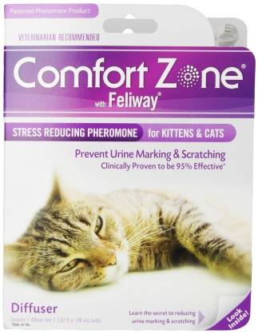
Before Your LapLepard Bengal Arrives:
Prior to bringing home your loving kitten, we suggest setting up a 95% proven pheromone diffuser that will help calm nerves for both the transitioning kitten and any other present pets. This should be set up days before you pick your kitten up. It’s recommended to use one diffuser per floor and you replace the refill once a month. They sell a Comfort Zone spray that’s good for specific areas like for the cat carrier, which you will want to apply one hour ahead of picking up your kitten. This particular product is the most economical when purchased in bulk on Ebay from lot auctions.
Picking up your LapLepard Bengal:
Please bring your remaining amount due in cash (no checks), a cat carrier, and a cooler.
Your Bengal kitten will have already received the first round of core vaccinations and deworming before you arrive on . You will need to bring a small cooler with an ice pack to store your kitten’s second and third round of core vaccinations and dewormerings that will be given to you when you arrive. The vaccinations will come in two vials for each dose and you will need to pour the liquid from one vial into the vial with the powder and gentle roll the vial between your palms until it is mixed well. You then suction up the dose into a given pipette and apply half into each nostril. These vaccinations are intranasal and can be applied by you at home at the 12 week . and 16 week mark. Do expect some level of sneezing for the first couple of days after application and the possibility of a slight fever as the immune system is activated. If your kitten acts sickly by being too sleepy and/or not eating than you should take your kitten to the closest animal hospital, although complications due to vaccinations are very rare and even less so for the new intranasal kind. Another advantage to having the intranasal vaccinations is the fact it eliminates injection site sarcomas, a type of cancer that happens from subcutaneous vaccinations.
You will also receive a kitten care gift bag that will include your kitten’s health record, official purebred TICA paperwork that will allow you to register your kitten online at the TICA database for a small $12 fee, a copy of your signed contract, this kitten care sheet, a Bengals Illustrated New Kitten booklet, Dr. Elsey’s Litterbox Solutions booklet, a Revival Animal Health booklet, toys, and a small baggy of food.
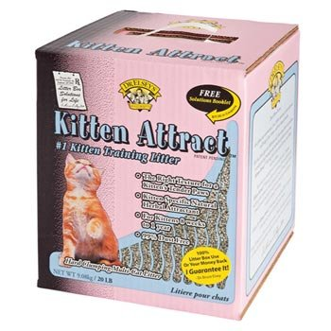
After Your LapLepard Bengal Arrives:
We suggest you set up his/her food, fresh water, and clean litterbox in a room isolated from other pets. We recommend this "quarantine" period last about 3 weeks. It is important that your kitten is given adequate time to settle in to his/her new home before introducing other household pets. After your kitten has become comfortable around you and your family, we recommend slowly introducing him/her to the household pets and other rooms (this time frame varies depending on individual cat/kitten). Please supervise all visits until you are certain your kitten is safe and comfortable.
Your kitten will come litterbox trained but be aware there will be a transition period in which the kitten must become use to your home environment so do anticipate a little retraining. Keeping the initial living space small and litterboxes close will help facilitate. Dr. Elsey’s Kitten Attract litter was used to initially train your kitten. Please start off using this litter until good litterbox habits are established (up to 1 month). Afterwards, you can gradually switch to an all-natural litter. Stay away from clay litters. If litterbox problems persist, it is recommended to go back to Kitten Attract and use the recommendations found within the enclosed pamphlet from Dr. Elsey’s Litterbox Solutions.
If you do choose to feed your kitten different food, do expect a short period of loose stools while the kitten’s digestive tract becomes familiar with the new food. Your kitten will be used to being handled and being in a home environment with children but do expect your kitten to be initially cautious or timid in his/her new environment. Given time and space, your kitten’s natural curiosity should eventually lead him/her to explore your new home and become comfortable. This transition time period is different for every kitten.
Feeding Your LapLepard Kitten:
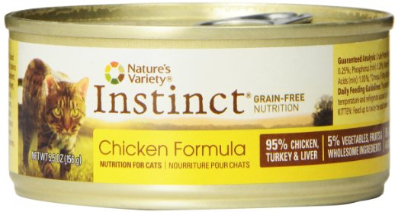
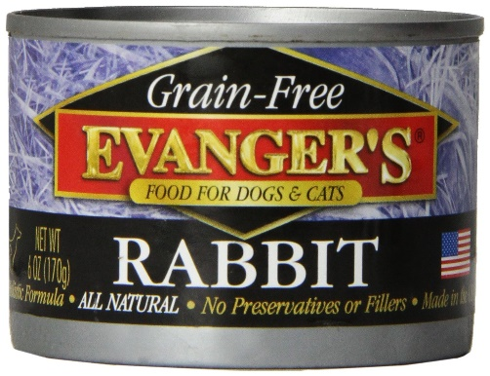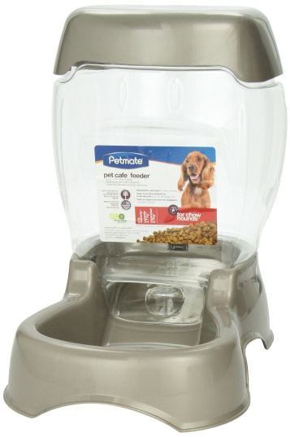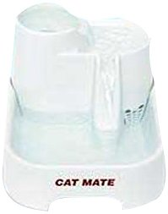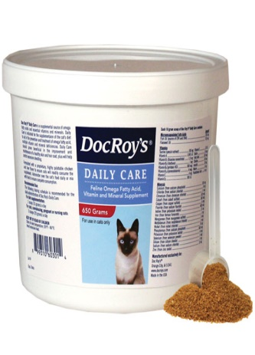*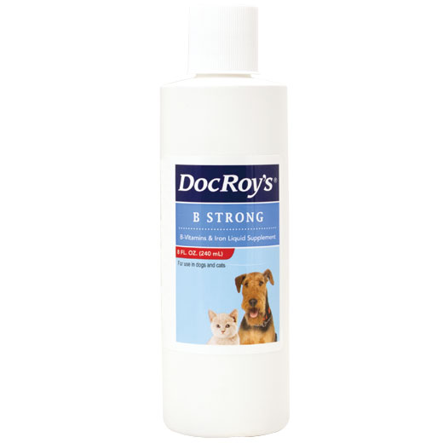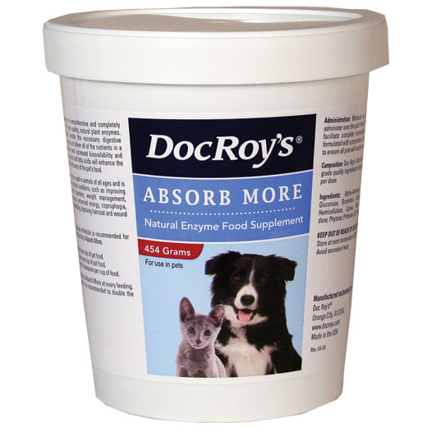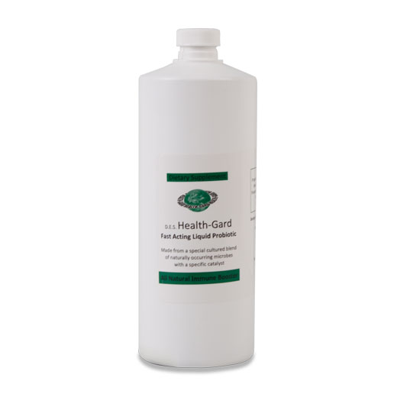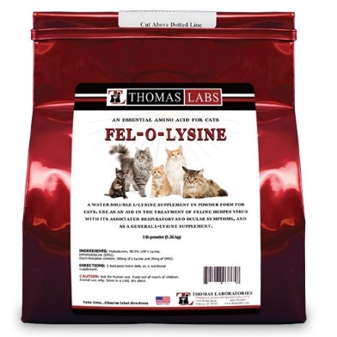
Cats are naturally carnivores and Bengals are more so due to their ALC hybrid roots. Therefor you should feed your Bengal only dry and wet food that is high in protein and grain-free. There are several brands in the market that fit these 2 crucial criteria. Wet food is essential everyday and helps with hydration. Dehydration due to a dry food only diet will stress the Liver and kidneys and lead to a domino effect of problems. It is encouraged to add even more water to the wet food. You can also add into wet food or offer separately other nutritious liquid like broth, gravy, or beaten raw egg. Initially we cut up the dry food in a blender to help kittens with tiny teeth eat. This can be helpful until the kitten reaches 16 weeks old. Suitable food brands include: Taste of the Wild, Acana, Wellness, Evanger’s, Blue Wilderness, Innova Evo Ancestral diet, Nature’s Variety Instinct, and Earthborn Holistic Primitive Feline. One 5 oz can of wet food can be given once a day at dinner time. When you give your kitten it’s wet food use a “food call” that signals it’s time to come and get fed. This offers a chance to train your kitten to come to this “food call” so that should you ever need to locate your kitten you can use this call.
Within the food we add a variety of premium supplements from Revival Animal.com that we highly recommend that include: Doc Roy’s Daily Care Feline for vitamins/minerals/antioxidants, B Strong that boost Metabolism, Absorb More and D.E.S. Health-Gard Probiotic which help with digestive health, and Lysine which boosts immunity. We want our animals to live their long lives free of later aging-complications. We believe an ounce of prevention is better than any cure. While supplements add an additional cost it balances itself when you have to feed less food, have less waste to remove, and less weight-related problems. Cats eat according to their nutritional needs. A cat absorbing more of their food and with less nutritional gaps will overall eat less food. An overweight cat has a nutritional deficiency. This is also why food can be continuously left out all day.
Water fountains are more attractive to the water-loving Bengals because instinct tells animals that running water will be less harmful to them than stagnate water. However, water fountains do require some maintenance as motors can become clogged. Also, it’s important to take out any included filters and instead use filtered water. Filters trap bacteria and particles. Keep the water and food bowls close together but not next to each other as any moisture can ruin the dry food, at least 2 feet apart. More water stations also increase hydration for “out of sight, out of mind” definitely applies. All carnivores have a low thirst drive.
Litter:
We recommend only all-natural litters. Clay litter is not desirable because it absorbs nothing, creates a lot of dust that coats lungs, is harmful to swallow which curious kittens can do, and is hard on the paws. Corn cob litter is the better alternative because it is safe for kittens to swallow, is virtually dust free, it can be easily scooped since it clumps, it absorbs waste and odors well, and the sand-like consistency doesn’t hurt their paws. We recommend: The World’s Best Cat Litter, Multi-Cat version with Lavender oil in one litterbox per 2 cats placed in a quiet area. Your kitten's litterbox is currently being scooped twice daily. Plastic heavy duty litterbox liners make changing the litter out easier as well as keeping the actual litterbox clean and sanitary.
Exercise:
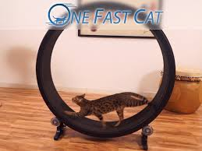
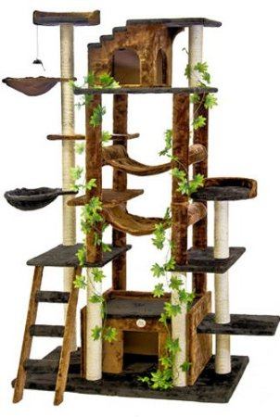
We strongly recommend having plenty of toys readily available for your new kitten. Bengals are very active and require plenty of toys to "keep them out of trouble". We suggest also investing in a cat tree for your new kitten which most come with built-in irresistible sisal scratching posts. They are relatively inexpensive and last a very long time. Bengals especially love residing in high places and hammocks. Cat wheels are also wonderful options to stimulate your Bengals. You can get a cat wheel with free shipping for $249 at onefastcat.com
Please Share With Your Veterinarian:
Never vaccinate for FIP. Clavamox is the ideal antibiotic for Bengals. All Breeding Bengals were already tested negative for Feline Leukemia and Aides. If you choose to test your kitten(s), opt for the definitive PRA test. SNAP tests are quick and dirty screenings that have been proven to yield an 80% “false positive” rate.

