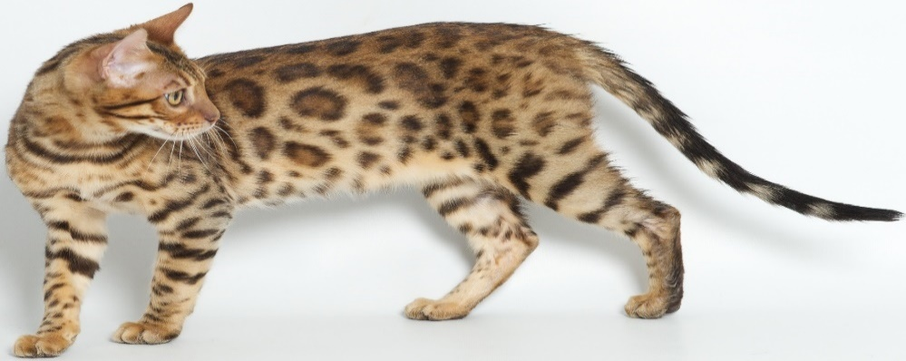
Registered TICA Bengal Breeder
Lap Leopard Bengals
Monique Dillon
168 Ocean Ave, New London , CT 06320
(860) 857-7798
www.LapLeopardBengals.com
LapLeopardBengals@aol.com

This contract is between the Seller, Lap Leopard Bengals (referred to as LLB) and Buyer:
Name:
_________________________________________________________________________
Address:
_________________________________________________________________________
Phone:
(__ ___)____________-________________E-mail_____________________________________
How did you learn about LLB: please circle
Search engine (google,yahoo,bing), TICA, Bengals Illustrated, Bengal Classifieds, other:
Purchase Price
____________________________________________Deposit________________________Received
Balance Due @ 8wks Desired kitten color/gender/parentage

____________________________________________

Chosen Kitten Information: DOB ______________________Sex__________Color__________ ________

SIRE ________________________________ DAM ________________________________

PURCHASER AGREES TO THE FOLLOWING: Please initial all spaces.

All sales are final. No returns, refunds, or exchanges except what is outlined by the terms of this agreement.
We require a $200.00 non-refundable PET deposit to hold a PET kitten and a $1,000.00 refundable Breeder deposit to hold a Breeder/Show kitten. No hold shall be placed upon a kitten until the full deposit is received regardless if partial payments have been made. The deposit will be put towards the purchase of the kitten and is non-refundable or transferable on a present particular kitten. Only if said kitten becomes unfit for sale will the deposit be put towards another litter/kitten.

_______The balance for the kitten is due when you receive your kitten (including shipping if applicable). LLB reserves the right at any time to refuse the sale of any kitten/cat. Should LLB decide to not allow the sale of a kitten, all money paid for such kitten is to be refunded. Kittens and cats are the sole property of LLB and should be considered as such until the cat or kitten is in possession of buyer and the ownership contract has been signed by both parties. No kitten shall be released until the full balance is paid. Kittens left with LLB for more than 7 days past the release date will be subjected to the normal $40/week kitten sitting fee. If buyer doesn’t come to pick kitten up by the time the kitten reaches 12 weeks than the deposit is forfeited and the kitten may be sold to another buyer.

This cat/kitten will never be sold, transferred, leased, or given away to any pet shop, research laboratory or similar facility. This cat/kitten will be kept indoors and not be allowed to roam freely outside. This cat/kitten will never be de-clawed or de-meowed. If for any reason at any time you do not want this cat/kitten, you will return this cat/kitten back to me free of charge. If shipping is required, LLB will reimburse $250-350 for shipping fees.

This cat/kitten is being purchased for Breeding: _______ Pet: _______

. If this cat/kitten is found to be neglected or mistreated, Purchaser will surrender said cat or kitten to Seller immediately. This cat/kitten will receive excessive amount of tender loving care, will be fed the best possible diet, will receive substantial amounts of entertainment, and will be treated with the utmost respect so that he/she may realize its full potential. This cat/kitten will be identified by its full registered name on websites and/or advertising at all times.

______If this cat/kitten is purchased as a breeder male, Purchaser agrees not to use this cat for outside stud service. No co-ownership, transfer of queen's ownership, leasing, or other devious means of circumventing this restriction will be tolerated. Any queen bred by this stud, and subsequent litter must be owned entirely by the owner of the stud.
______If this cat/kitten is purchased as a breeder female, Purchaser is allowed to use an outside stud service only if the stud is TICA registered and vet tested. Purchaser agrees to breed this cat only with other TICA registered Bengals. Failure to honor this will result in forfeiture of the cat and registration papers back to LLB.
_______If this cat/kitten is purchased as a pet, Purchaser is to spay/neuter this kitten by the time the kitten reaches 6 months of age. Seller will give Purchaser said kitten’s TICA paperwork when Purchaser provides proof of spay/neuter from a licensed veterinarian. Failure to provide proof of spay/neuter will result in the forfeiture of registration papers and buyer will pay seller $3,000US.
. It is the purchaser's sole responsibility to comply with all municipal, state, and national laws in respect to this kitten/cat. It is the Purchaser's sole responsibility to comply with all international shipping country and receiving country's export and import laws, licenses, permits, vaccination and testing requirements, and CITES requirements if traveling with this kitten/cat and for international import/export of any progeny of this kitten/cat. The Seller cannot and will not be responsible for any refusal by any authority to allow international import/export of any progeny of this kitten/cat. The Purchaser warrants and promises that this cat and/or any of its offspring shall not be sold, re-sold, or leased to anyone residing in the state that LLB resides in.
. If this contract is breached in any way, Purchaser will owe the seller a fee of $3,000US for breach of contract to the Seller, Monique Dillon, over and above the original price each and every time the contract is breached. Once the contract is breached, Purchaser is to surrender the cat/kitten back to the Seller without refund and at the Purchaser's expense with signed Transfer of Ownership. Purchaser agrees that if any legal action needs to be taken that all legal fees will be Purchaser's responsibility for both parties and it will be held in seller's current state and county of residence. Disputes will be settled between Seller and Purchaser privately and will not be aired in a public forum including Yahoo Group lists and FaceBook or any other media.

GUARANTEES:
Deposits on a particular present kitten are non-refundable and non-transferable but will guarantee the hold on that kitten. Deposits on a future PET kitten are also currently non-refundable as the wait time is currently 8-12 months. LLB anticipates moving within this time frame and should we move before you get your kitten, you are responsible for an additional $250-350 in shipping fees to have us ship you your kitten to the nearest local airport.

Your kitten will arrive with their 8 week core vaccinations and deworming’s already given, their personal health record, kitten care sheet, TICA registration paperwork, a kitten care package, and with plenty of socialized curiosity.

It is recommended to have the cat/kitten examined by a licensed veterinarian within 72 hrs of arrival. If it is found to be medically deficient with an untreatable or life-threatening problem, it must be reported to the seller immediately. Upon its return, it will be replaced with another cat/kitten of equal value. No cash refunds. The cat/kitten cannot be returned if it has been exposed to another cat which has not been currently tested for FeLV and FIV. There are no guarantees against FIP. It is the responsibility of the buyer to provide immediate veterinary care to any cat/kitten showing signs of illness or distress and failure to do so will render any guarantee null and void. All veterinarian fees are the sole responsibility of the Purchaser. We will provide the 2nd & 3rd series of core vaccinations and deworming’s for 12 and 16 weeks respectively, except for the rabies vaccine, to ensure the full round of vaccinations is given. Additional fees may be required for shipping.

This cat/kitten is guaranteed against congenital defects inherited by the parents and HCM for the first 2 years from the purchase date of the cat. Should the cat die as a direct result of a congenital defect or HCM, the cat will be replaced ONLY if an appropriate necropsy is performed by a licensed vet and a vet's certificate is provided proving that the cause of death was directly related to a congenital defect or HCM. A replacement will be made of a cat of comparable quality and value, as available, at the discretion of the breeder. No cash refunds. Buyer is responsible for all shipping fees should they be required.

Due to the many factors involved in rearing and caring for this kitten that are beyond the control of the seller, there are no guarantees on fertility or temperament. There are no guarantees given on future health, show achievements, or reproduction capabilities of cats/kittens sold with breeding rights. Seller verifies that there are no precluding reasons why a kitten/cat sold with breeding rights should be unable to produce/sire normal litters. If however, a kitten/cat sold with breeding rights is unable to sire/produce young after 2 years of age and several breeding attempts with proven fertile cats, tests will be done at the expense of the buyer to determine fertility. If testing finds this cat to be sterile, due to a congenital problem such as malformation or absence of organs, the Seller will replace the cat/kitten with one of equal quality. The said kitten/cat will be returned to the Seller prior to sending a replacement kitten. Queens are not guaranteed if a proven male does not reside on premises. There is no guarantee against pyometra. The process of breeding is not to be taken lightly, and breeders must take measures to educate themselves on the subject. There are no guarantees against eventual developments of lockets or tail faults. No replacement will be given for any cat that has been bred and produced a litter (purebred or otherwise). If there is a question of whether the cat has been used for breeding, Purchaser agrees to grant Seller full access to veterinarian and TICA records.

This contract is legally binding to the Purchaser and Seller in this transaction and is non-transferable to other parties. The buyer agrees to the terms and conditions, and to pay as stated. If Buyer or Seller commences any legal action as a result of this contract, Buyer agrees that the place of venue of such action be in the city and state the seller resides in. Any legal fees, expenses, disbursements, and all other costs related to upholding this contract will be paid by the Buyer.

(Seller)________________________________________________ _________________ Date:____________

(Buyer)_______________________________ Printed__________________________________Date:___________

